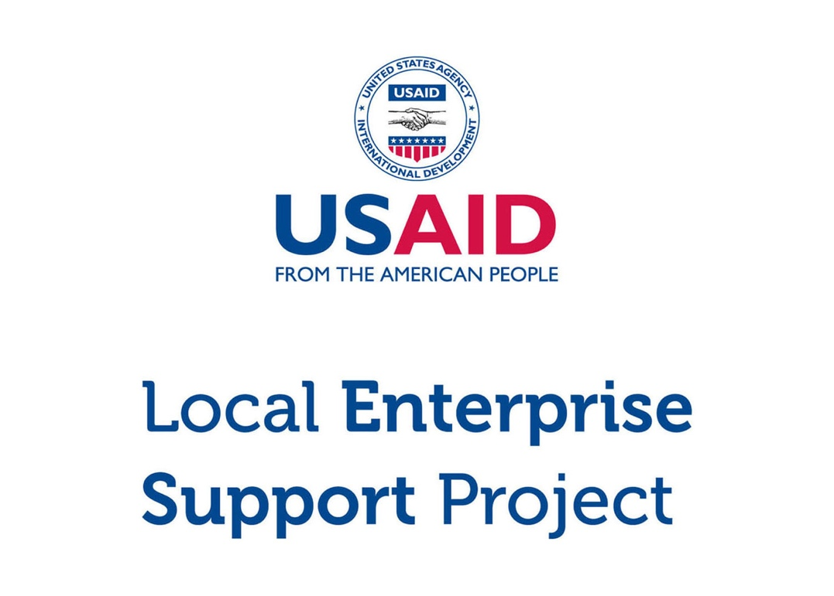

**Micro and Small Enterprise (MSE) Survey**

Results for Amman Governorate

Tuesday, March 15, 2016 (version 2)

**DISCLAIMER**

The USAID Jordan Local Enterprise Support (LENS) Project is funded by the United States Agency for International Development (USAID) and implemented by FHI 360. This report is made possible by the generous support of the American people through the United States Agency for International Development (USAID). The contents are the responsibility of FHI 360 and do not necessarily reflect the views of USAID or the United States Government.

**ACKNOWLEDGEMENTS**

This report was written by Bryanna Millis and Rafael Pilliard-Hellwig, with contributions from Faisal Awartani, Muin Khoury, Edmund Morris, and Jonathan Peters. The report was translated by Dania Mousa and Shadi Al Rawashdeh.

**ERRATA**

The current version of the reports for Amman, Irbid, and Zarqa contain graphs and figures that differ slightly from an initial release of the governorate reports. This is due to a post-stratification re-weighting of the survey data that adds accuracy and brings the methodology in line with that used in the Aqaba, Karak, and Tafilah reports.

# Highlights

|  |  |  |
| --- | --- | --- |
| 33,455  MSEs |  | MSES ARE THE MAJORITY > There are an estimated 33,455 micro and small enterprises in Amman. Four sevenths are single-person businesses, and roughly the same proportion operate in retail and trade. |
|  |  |  |
| 8.8%  WOMEN |  | MSES ARE MALE-DOMINATED > Only 8.8% of Amman’s MSEs are female-owned. Women with MSEs are more likely than men to earn less, to operate out of home locations, and to work out of necessity. |
|  |  |  |
| 4/5  ARE REGISTERED |  | MSES EXIST ON PAPER > Despite the fact that most MSEs do not pay tax and only half have employees, four in five are nonetheless registered with the Ministry of Industry and Trade. |
|  |  |  |
| 6 YEARS  IN EXISTENCE |  | MSES ARE NACENT > The typical MSE has been in business for six years. 77.9% believe they will continue to operate for at least 3 years. |
|  |  |  |
| 300 JOD  PROFIT |  | MSES STRUGGLE TO GET BY > MSEs that make profit report a median bottom line of 300 JD per month (usually excluding the MSE owner’s own salary). 63.4% of MSEs are losing money or struggling to live comfortably. |
|  |  |  |
| 20% USE  COMPUTERS |  | MSES ARE DIGITALLY ABSENT > Only 20.3% of businesses use a computer in the course of their work. Less than one in five uses social media either for work or personal purposes. |
|  |  |  |
| <6%  PENETRATION |  | MSES LACK COLLECTIVE POWER > Memberships in associations are weak. With the exception of the chambers, the penetration rate for trade associations, business groups, and cooperatives is below 6%. |
|  |  |  |

Table of Contents

Introduction 5

General Demographics 6

Contracts 18

Workforce 19

Firm Performance 22

Access to Finance 25

Systems, Processes and Networks 27

Policy and Regulations 29

Data was compiled using data file “**new_lens_usa_fix_pswt.sav**” (MD5 hash: 3958a9180d)

# Introduction

## About USAID LENS

The USAID Jordan Local Enterprise Support Project (LENS) is a five-year project to encourage the long-term economic growth and development potential of underserved Jordanian communities. USAID LENS combines local economic development with private sector development initiatives to help create jobs and sustainable growth that is inclusive of women and youth.

LENS’ systemic approach to local economic development is meant to catalyze inclusive local and regional economic networks in a business-enabling environment, while developing the competitiveness, sustainability and growth of micro and small enterprises.

## About the Survey

Although Jordan’s economy is dominated by micro and small enterprises (MSEs)[1], relatively little is known about them. To overcome this informational gap, USAID LENS conducted a survey of MSEs in 2014-2015 to better understand Jordanian enterprises and to assess the major barriers and opportunities for growth. The study covers general demographics, workforce trends, firm performance, access to finance, processes and networks, and the impact of the Syrian refugee crisis.

The survey consists of 86 questions in a double sampling design with stratification. The data gather representative information for all MSEs operating in the governorates of Amman, Zarqa, Irbid, Karak, Tafilah, and Aqaba.[2] Although the study is not intended to be national in scope, the target population of the six areas collectively capture 60% of the kingdom’s population.

As a complex survey, the research design was undertaken using probability sampling in two phases. In the first phase, 977 geographic clusters were randomly selected from districts in each area. From these clusters, 97,347 households were contacted through door-to-door interviews, of which 10,197 reported owning a business. A sub-sample of 6,385 MSEs was then drawn, stratified by sector governorate. 4,721 of these MSEs were then successfully surveyed (1,297 in Amman).

This report focuses exclusively on results from the governorate of Amman. Findings are taken from USAID LENS’ MSE survey, and can reliably be generalized to all MSEs within this geographic boundary.[3]

# General Demographics

## Firm Characteristics

Based on the survey research, there are an estimated 33,455 MSEs in Amman.[4] An overwhelming majority of these are owned by men (91.2%).

The proportion of man-owned to woman-owned businesses is generally consistent with government figures. According to the Department of Statistics (DOS), women account for only 13.0% of the Jordanian labor force nation-wide. According to the survey, only 12.2% of businesses in Amman either employs women or is managed by one.

|  |  |  |  |  |  |
| --- | --- | --- | --- | --- | --- |
| **Demographics (Amman)** |  | **Sample** |  | **Population Estimate[5]** | |
|  |  | *n* = 1,297 |  | *N* = 33,455 | % of group |
| **By Select Sector**[6] |  |  |  |  |  |
| Tourism |  | 114 |  | 2,949 | 8.8% |
| ICT |  | 62 |  | 677 | 2.0% |
| Transport |  | 244 |  | 6,143 | 18.4% |
| Food Processing |  | 120 |  | 3,137 | 9.4% |
| Other |  | 757 |  | 20,549 | 61.4% |
| **By Sex of Owner** |  |  |  |  |  |
| Male |  | 1,182 |  | 30,502 | 91.2% |
| Female |  | 115 |  | 2,953 | 8.8% |

Transport accounts for the largest of the four sectors above, representing 18.4% of all MSEs in Amman. Food Processing follows with 9.4%, Tourism with 8.8%, and ICT with 2.0%. MSEs outside of these select sectors account for the remaining 61.4%.

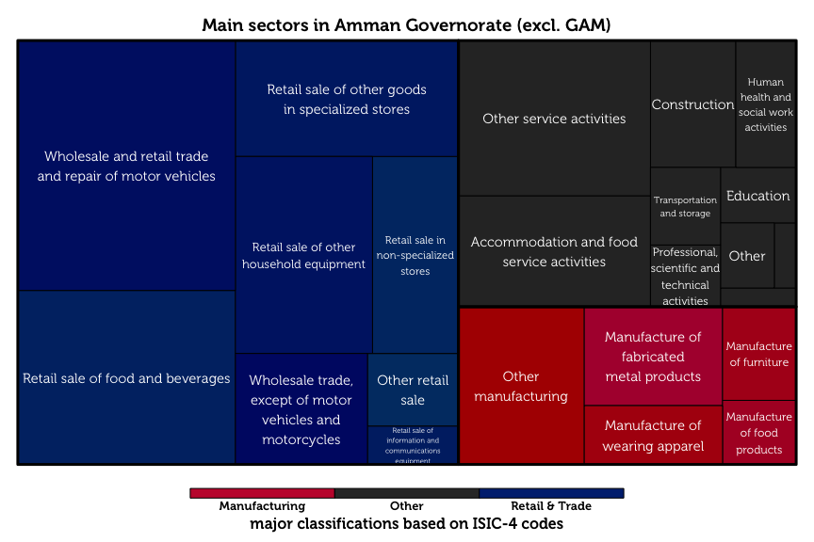

The treemap diagram above shows the relative sizes of each business category, as classified by ISIC-4 codes. Retail and trade dominates as the largest sector (56.6%), followed by manufacturing (16.1%).

## Respondent Characteristics

The typical MSE owner in Amman is a married, 40-year old male with secondary school as his highest level of education. Two thirds of these owners have families of moderate size (4 – 7 members). Male business owners are typically the primary earners of their household, in sharp contrast to female MSE-owners, who are rarely the breadwinners for their families.

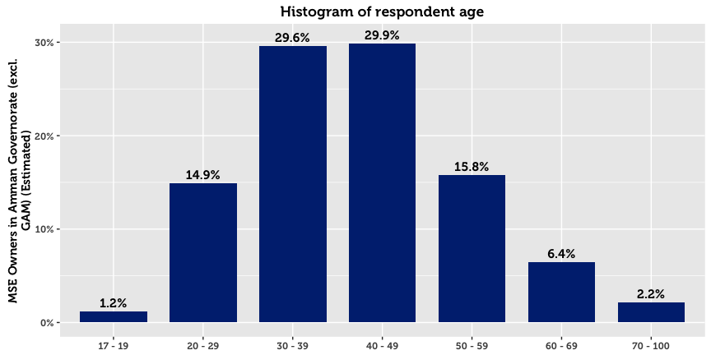

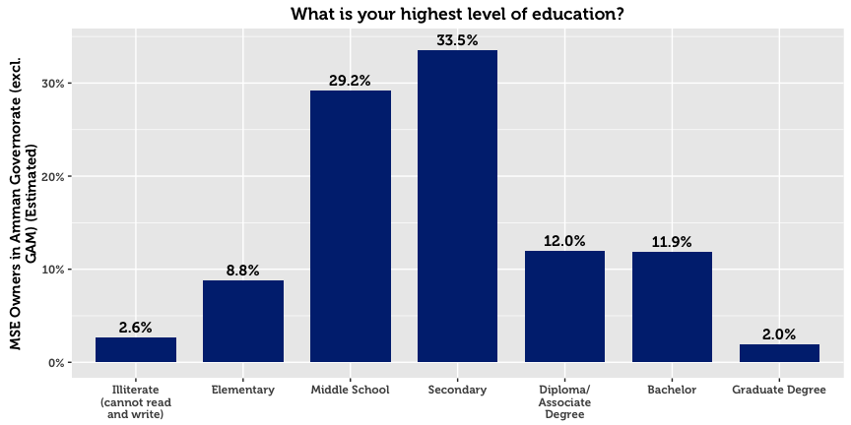

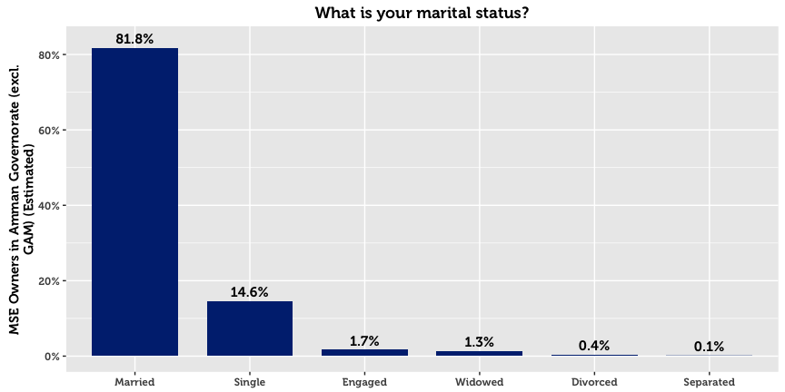

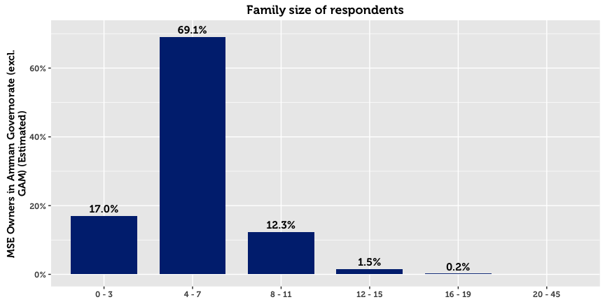

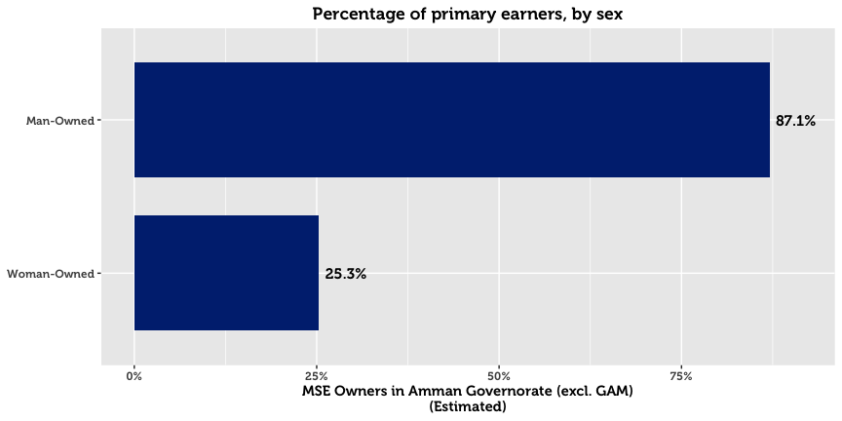

## Establishment, Registration & Business Continuity

The survey reveals that roughly half of the MSEs in existence today were established in the last six years. Going back further, 75% of MSEs registered after 2000. Four in five of all MSEs in Amman believe that they will continue with the business over the next three years.

A higher number of businesses are registered with the Ministry of Industry and Trade (MoIT) than anticipated. 79.7% of all MSEs in Amman are registered with the Ministry, a figure that is dramatically higher for man-owned businesses (81.7% for men compared to 58.9% for women). Registered businesses tend to be older than unregistered businesses by an average of three years.

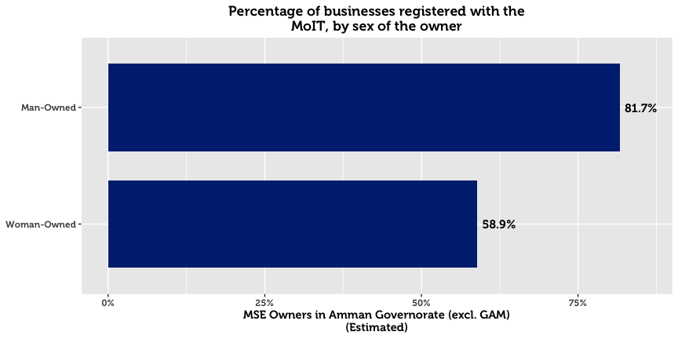

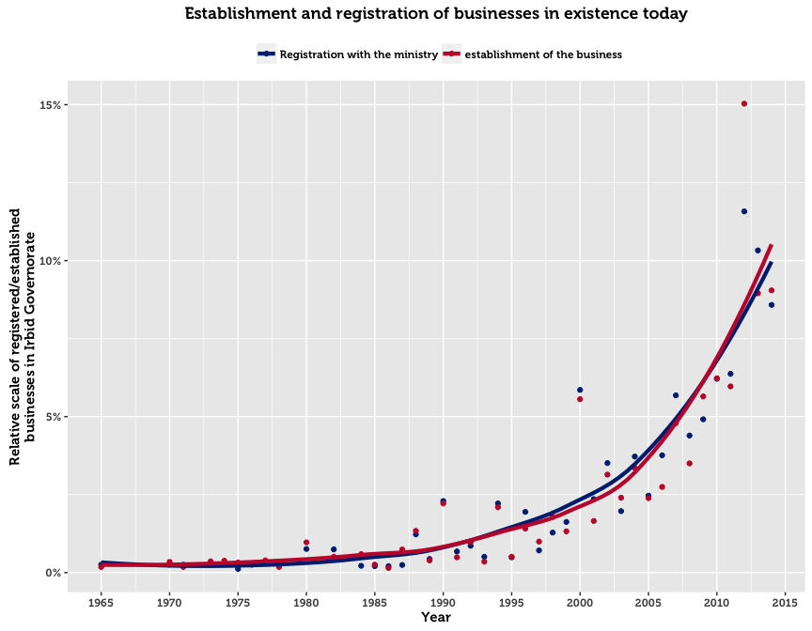

The above chart plots the frequency of business establishments and registrations by year. Almost all registered businesses were established and registered in the same year. The upward trend in registrations over time is explained by three factors: (1) growth in the population of Jordan, (2) initiatives by the government to increase awareness and simplify the registration process, and (3) survival rates. The third reason implies that businesses that existed in the past but no longer operate become excluded from the sample. Such cases may have gone out of business for financial reasons, or ceased to exist due to the passing of the owner.

For those who chose to register, two main reasons emerge. The first reason is that registration is legally compulsory for their type of business (cited by 47.3%). The second is that MSE owners fear fines or harassment by police and authorities (cited by 38.0%). The support available from the government once registered, availability of insurance or official protection, and access to finance were not considered to be important primary motivations for business registration.

On the flip side, the dominant explanation given by half of the unregistered MSEs in Amman is that they see no benefits from officially registering their business (33.0%). 46.8% of MSEs who did not register responded with the category “Other” when asked for a reason.

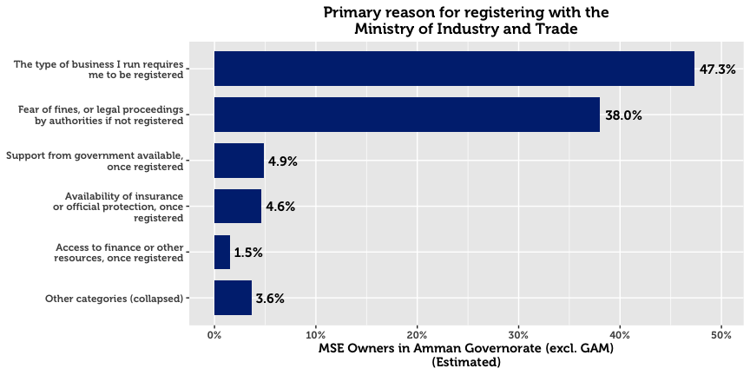

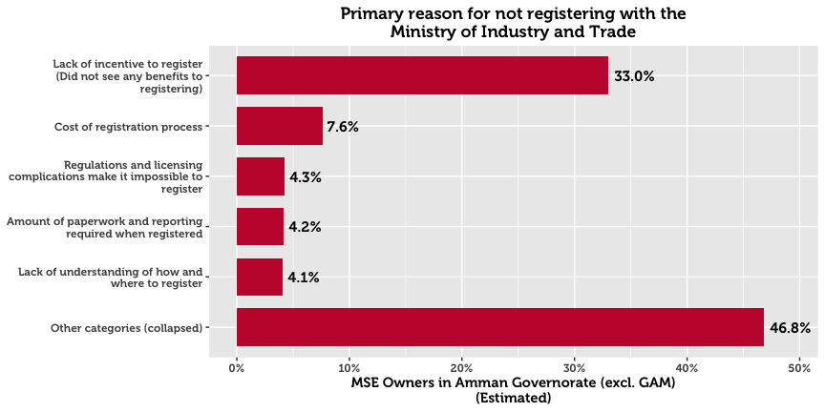

## Seasonal Business

An estimated 91.5% of MSEs operate all year round. Woman-owned businesses are 1.7 times as likely as man-owned businesses to be seasonal.

## Working Hours

45.1% of business owners work over the recommended 49 hours a week. This trend of long work hours is particularly pronounced in the ICT and Tourism sectors.

## Location of Conducting Business

In Amman, the majority of business is conducted from a fixed location outside of the home (90.8%). This is more pronounced for men than women, as men are 1.3 times as likely to operate out of a fixed location out of the home.

In stark comparison, 4.4% of MSEs are home-based.[7] Gender differences on this dimension are high, with 29.4% of woman-owned businesses operating from their homes compared to 2.0% for man-owned businesses. Home-based businesses are most commonly found in manufacturing wearing apparel, other personal services, or retail. Only 2.6% of all businesses are run at changing place public spaces (such as markets). Those who participate in these changing locations are almost exclusively male.

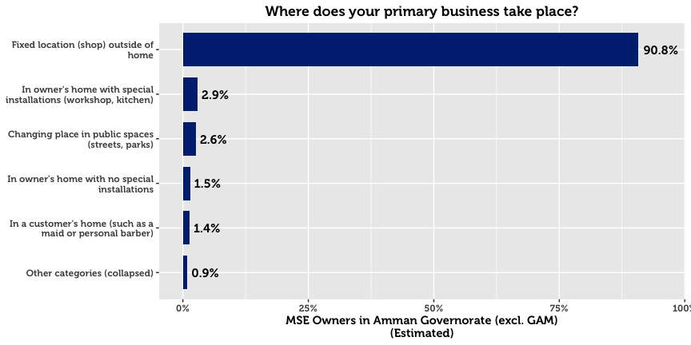

## Business Motivation

The primary motivation for starting an MSE in Amman is the desire to become a business leader. 46.4% of MSEs state that this the main reason they started their business. The second most popular reason is an interest in the industry. MSE owners in the Transport and ICT industries chose this reason more frequently. The third most frequent reason is to generate income for the family. This response was more common among female owners (31.5% of women cited this as their primary motivation, compared to 13.5% of men). This suggests that women may be under greater pressure to provide additional income to support family. It is noteworthy that the first two reasons—which pertain to a positive driving force rather than necessity—represent 67.5% of businesses.

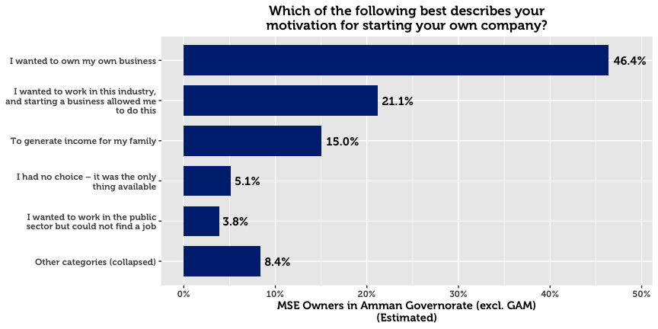

## Conducting Other Business

A small number of MSE owners have more than one business or income-generating project (8.1%). Men are 1.5 times as likely as women to have another business.

## Legal Ownership of Business

70.9% of businesses in Amman are self-owned. For the others, 9.8% are owned by a male family member, and 7.1% by a male non-family member.

## Form of Incorporation

The majority of MSE owners who are formally registered exist as sole proprietorships (82.3%). Others are typically either General Partnerships (6.8%) or Limited Liability Companies (5.7%). These last two categories are more common among companies that have employees. This is not surprising; given we would expect this to be the case with bigger enterprises.

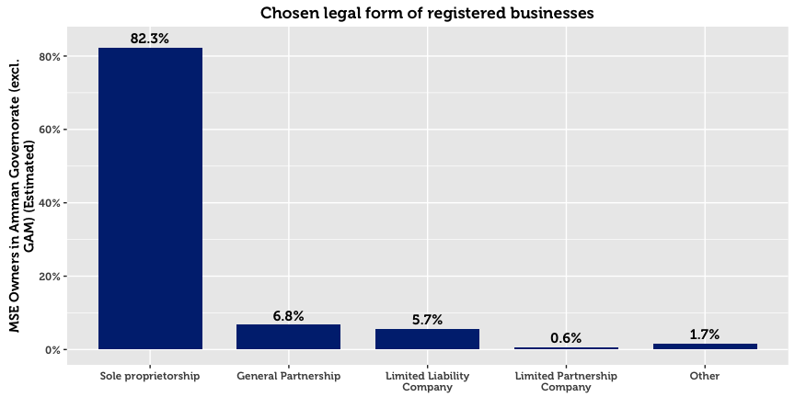

## Licensing

MSEs are by and large licensed with their municipalities. However, there exists a small subset that are registered but not licensed (1.3%), and a subset that are licensed but unregistered (2.1%). This may point to either a) misunderstanding of the question on behalf of the respondent, b) an expired license from the municipality, or c) an informal or illicit acquisition of a license from the municipality. As one might expect, home-based businesses and single-person businesses have far higher chances of being unlicensed.

The three primary reasons cited by MSE owners for not being licensed are that they see no benefits to doing so (20.7%), that it is not required for their business (10.9%), and that the owner does not want to pay licensing fees (10.4%). Half of the respondents cited “other reasons,” perhaps due to reluctance to answer truthfully to a sensitive question.

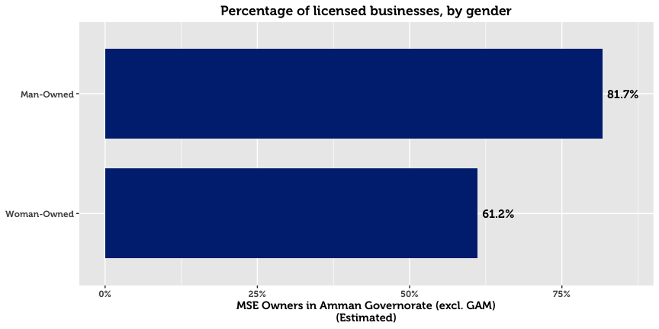

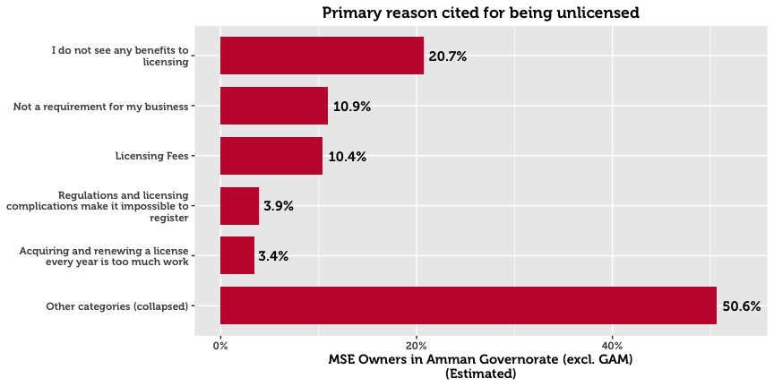

# Contracts

A large majority of surveyed enterprises never sign contracts: 83.7% of all MSEs. Only 8.2% report signing contracts either always or often. In the event of a dispute, almost no MSE owners opt to take legal proceedings. Nearly one in five reports that they will resort to doing nothing. Approximately two in three will resort to an informal meeting or family intervention.

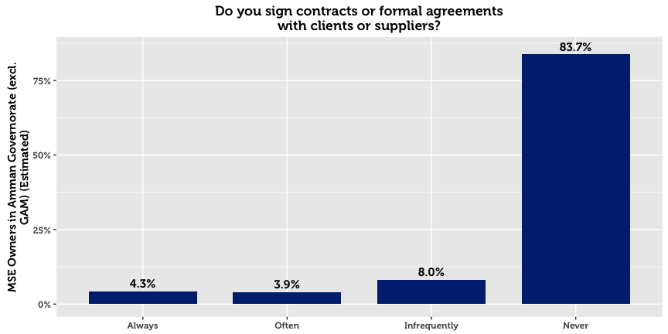

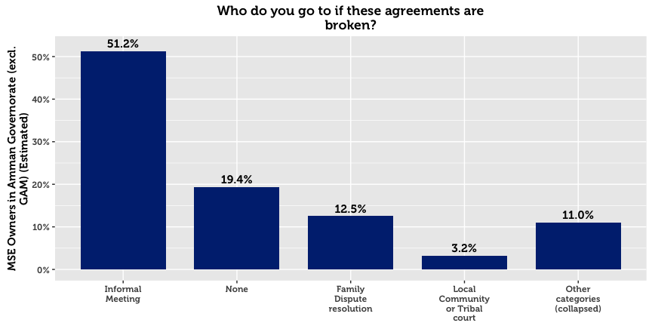

# Workforce

Just over half of Amman’s MSEs hire employees. The overwhelming majority of these enterprises employ less than three full-time workers across various sectors. Employment of women is rare, as only 6.9% of all MSEs in the governorate have female employees (12.2% for MSEs with employees).

Roughly speaking, one third of the MSEs with employees in Amman did not hire any new employees in the last year, and one third hired exactly one employee. Only 4.0% of these enterprises report employing workers below the age of 18.

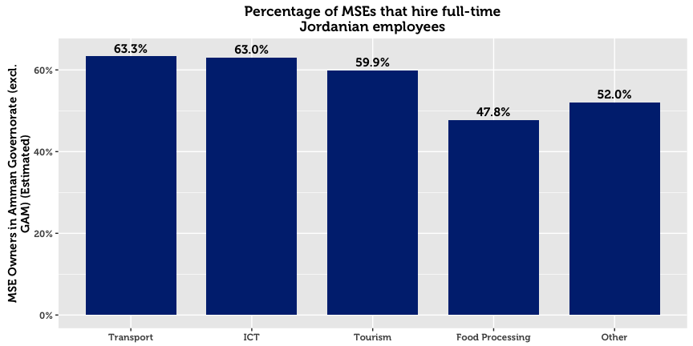

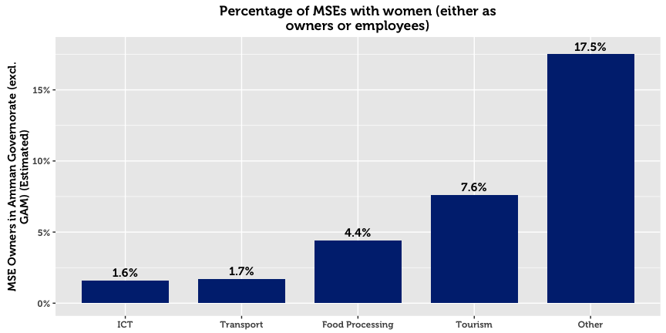

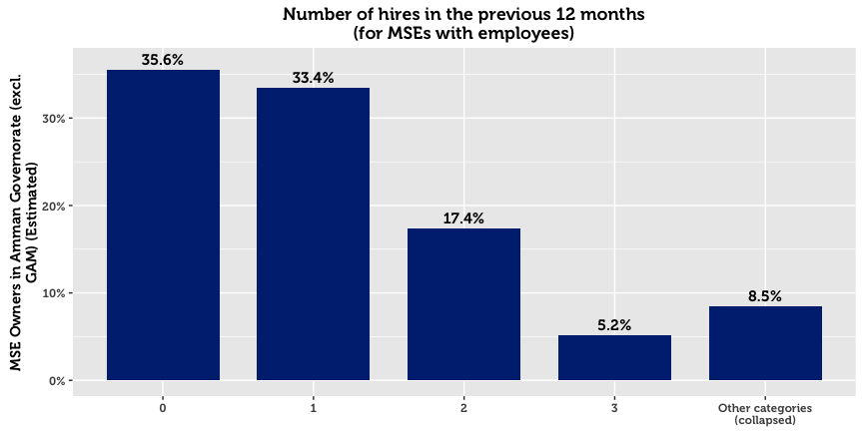

56% of enterprises hire between 1-3 workers. Of those that hire workers, 77.1% say that none left their business during the previous 12 months. Of those that experience talent loss, the major attributions are personal reasons, employees leaving to start their own business, salary demands, and unsuitable working hours.

|  |  |  |
| --- | --- | --- |
| **Primary Reason for Employee Loss (Amman)** |  | **All** |
|  |  | *N* = 4,183[8] |
| Personal reasons |  | 31.5% |
| Hired by a competitor for a better wage |  | 30.4% |
| Employee left to establish own business |  | 8.5% |
| The company could not afford a much higher salary |  | 8.2% |
| Unsuitable working hours |  | 5.3% |
| Other reasons |  | 16.2% |

## Employee Training

Only 32.1% of MSEs with employees offer their workers in-house training. Those that do typically offer technical training, informal mentorship, marketing assistance, or business management training. External trainings for employees are less common at 16.9%.

|  |  |  |  |  |
| --- | --- | --- | --- | --- |
| **MSEs that Offer Employee Training* (Amman)** |  | **In-House** |  | **External** |
|  | 32.1 %  *N* = 14,817 |  | 16.9%  *N* = 3,085 |
| Technical Training |  | 27.5% |  | 13.3% |
| Informal Advice/Mentorship |  | 22.2% |  | 8.8% |
| Marketing Assistance/ Information |  | 13.3% |  | 5.9% |
| Business Management |  | 12.9% |  | 5.2% |
| Human Resources/Soft Skills |  | 7.3% |  | 2.8% |
| Record keeping |  | 6.7% |  | 2.6% |
| Other |  | 9.4% |  | 6.5% |
| *\* Domain of analysis comprises only of companies with employees (86 total)* | | | | |

## External Assistance

It is estimated that only 5.0% of MSEs in Amman receive technical assistance.[9] A very small proportion receive assistance[10] from a private company (2.6%), a business service provider (1.9%), or from informal networks such as friends and family (1.7%).

# Firm Performance

63.4% of MSE owners report that they are either losing money or struggling to live comfortably. Only one third of surveyed enterprises maintain that their business allows them to live comfortably, and 2.9% claim that their company allows them to live well above their living costs.

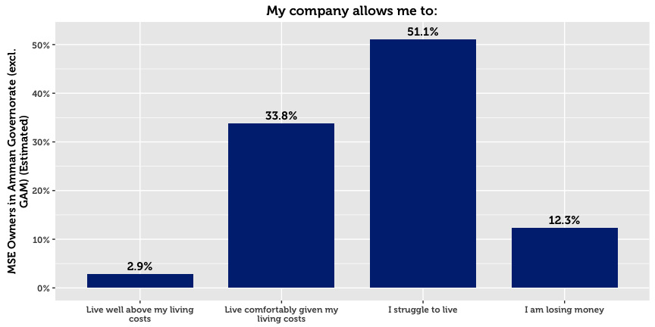

## Barriers to Economic Growth for MSEs

MSE owners were asked to state whether they agreed or disagreed that the following items represent barriers to the development their firms:

|  |  |  |  |  |  |
| --- | --- | --- | --- | --- | --- |
| **Barriers to Success (Amman)** |  | **All** |  | **By Sex** | |
|  |  | *N* = 33,455 |  | Men | Women |
| Low demand |  | 70.4% |  | 70.0% | 74.5% |
| Low purchasing power |  | 60.3% |  | 60.4% | 59.4% |
| Non competitive pricing of products |  | 25.7% |  | 25.6% | 26.4% |
| Lack of family support |  | 24.9% |  | 23.8% | 36.3% |
| Lack of human resource options |  | 24.8% |  | 25.7% | 16.5% |
| Lack of financial support |  | 24.7% |  | 24.1% | 30.9% |
| Cannot compete with quality of the products |  | 24.3% |  | 24.2% | 25.6% |
| Lack of appropriate suppliers |  | 20.5% |  | 20.1% | 24.5% |
| Lack of market information about the markets |  | 19.4% |  | 19.3% | 19.5% |
| Weak technical support or skills in this area |  | 18.2% |  | 18.1% | 18.3% |
| Lack of management skills |  | 18.1% |  | 18.3% | 16.8% |
| Lack of proper marketing skills |  | 17.9% |  | 17.8% | 19.8% |
| Unreliable transportation network |  | 16.3% |  | 15.9% | 19.9% |

The majority of firms believe that the major barriers are macro-economic in nature. Low demand and low purchasing power top the list of barriers to success. Despite the fact that most MSEs lack many formal processes and mechanisms such as a bank account or trainings, most do not perceive this a major gap or barrier. Similar to the other two northern governorates, fewer MSEs in Amman indicated that a lack of appropriate suppliers was a barrier to development compared to the governorates of the south (20.5%, compared to a combined average of 34.3% for the governorates of the south).

## Financial Performance

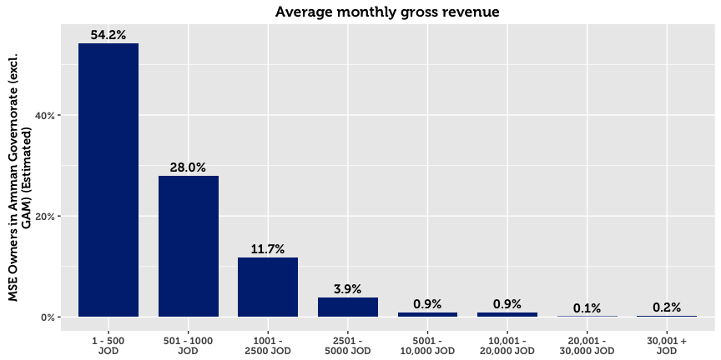

54.2% of MSEs in Amman report a monthly turnover of 500 JOD or less. However, 21.0% either refuse to disclose the exact amount, or do not know the amount. On average, women-owned MSEs, non-registered or home-based businesses, and single-person enterprises report significantly lower gross revenue.

Profit is a more sensitive issue: Although 48.6% report finishing the previous month in the black, 14.5% refuse to disclose the exact amount, and 37.0% do not know the amount. Nevertheless, of those who make profit and are willing to share this information, the median profit is 300 JOD. The median amount of savings per month in Amman is 200 JOD.

|  |  |  |
| --- | --- | --- |
| 10.2%  Of MSEs in Amman make  monthly savings |  | 74.9%  Of MSEs in Amman make no  monthly savings |

# Access to Finance

Three in four micro and small enterprises in Amman generate enough money to sustain themselves without outside financing. Although many MSE owners struggle to live comfortably, 31.7% say that they do not need a loan. Accordingly, financial institutions do not play a significant role in the economic development of most MSEs, evidenced by the fact that nine in ten MSEs have not applied for credit. Being in the Middle East, religious reasons also matter. Although the rise of Islamic Banking products makes this explanation less tenable, 29.7% of MSE owners cite religious prohibition as the main reason for not taking a loan.

The survey data suggests that MSE owners do not interact much with providers of credit, or even know about money markets. This is likely in view of the fact that most loan applications get approved (73.9% reported approval), that 13.9% believe that they only have one source of credit to their disposition, and that only 20.8% of MSEs have bank accounts. Of those who do not have accounts, 38.8% explain that they do not need one as their business requires working in cash, and 25.7% that low sales volumes do not justify having one.

Approved loans are typically used to buy more resources (materials or goods) (29.0%), to add new products or business activities (19.7%), to improve or upgrade products (17.9%), or to pay off personal debts (11.4%). Only in limited cases is financing used to pay off company debt (8.2%), or for the expansion or purchase of property (5.6%). On average, man-owned and target sector MSEs report a lower rate of success in their loan applications.

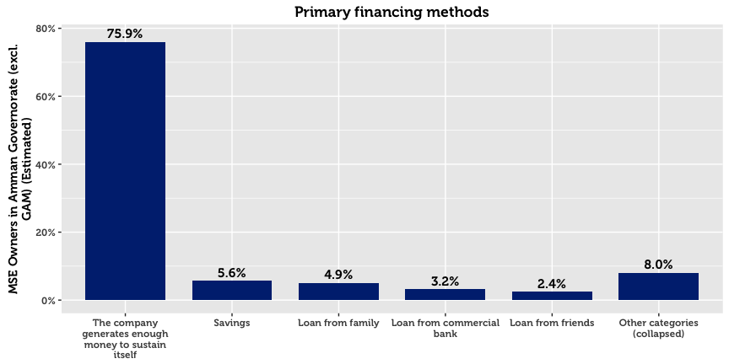

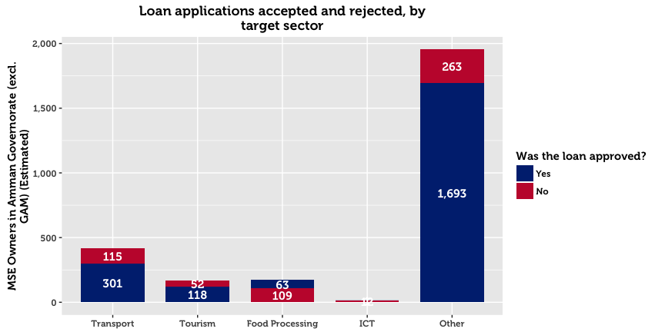

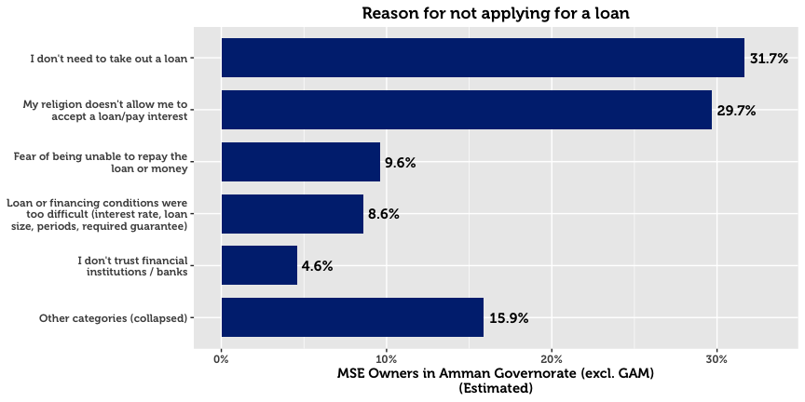

Of those who receive a loan, 43.0% receive it from a microfinance institution, and 34.5% from a bank. A less significant source is international donors or donor-funded projects (7.7%). A very small proportion report financing from government programs (2.2%) or private money lenders (2.7%). When asked about the primary reasons for choosing a specific institution, 31.7% cite that their institution of choice offers the best financial prospects. 24.0% cite that they chose a particular provider because they are easy to understand and follow simple procedures.

Men and women differ greatly in the amount of money requested in loan applications. Whereas men request an average of 1,712 JOD, women MSE owners are far more conservative at 487 JOD. These differences may be confounded by the fact that the sex of the business owner is strongly associated with the subsector and location of the business.

# Systems, Processes and Networks

Online and offline use of computers within MSEs is limited, at 27.6% of firms. Smart phones and ordinary mobiles are used by 38.4% and 61.3% of MSEs respectively. Over a quarter of MSEs in Amman use vehicles (27.8%), however the use of vehicles is more than twice as common in man-owned businesses compared to woman-owned businesses.

|  |  |  |  |  |  |
| --- | --- | --- | --- | --- | --- |
| **Resource Use (Amman)** |  | **All** |  | **By Sex** | |
|  |  | *N* = 32,846 |  | Men | Women |
| Mobile phone |  | 61.3% |  | 62.2% | 52.6% |
| Smart phone |  | 38.4% |  | 37.2% | 50.3% |
| Vehicle |  | 27.8% |  | 29.3% | 12.5% |
| Computer (with Internet) |  | 15.0% |  | 14.5% | 20.8% |
| Computer (without Internet) |  | 12.6% |  | 12.8% | 10.0% |
| Social media |  | 10.6% |  | 10.2% | 14.9% |
| Email |  | 8.0% |  | 8.1% | 7.7% |
| Public internet location |  | 5.8% |  | 5.9% | 4.8% |

Only 10.6% use social media as part of business operations. Naturally, this rate is more pronounced in the ICT sector, for which the digital environment is the main mode of work. The low number of social media users suggests that few MSEs understand social media, and that any target audience for social media is small. Only 8.0% use email to connect with suppliers.

## Corruption

With respect to bribery, 84.0% of enterprises report that they have never or rarely been asked for an informal payment.



## Financial Planning

71.9% of MSEs in Amman keep records of their finances manually. Only 6.1% keep digital records of their books, and 22.1% do not keep records at all. As one might expect, this is particularly the case for unregistered businesses. Less than half —38.0% —compare their business performance against their financial goals.

## Memberships & Access to Networks

For the most part, MSEs are not part of associations. With the exception of the Chambers of Commerce and Industry, no association garners more than 6% of MSEs in the governorate. These categories include professional or trade associations (5.3%), cooperatives (2.9%), youth groups (1.1%), micro-finance groups (1.0%), women’s groups (0.9%), women’s groups (0.9%), wards or village committees (0.8%), NGOs (0.8%), or informal savings or loan groups (0.6%).

Despite the fact that few participate in formal networks, 36.2% maintain they can get a meeting with the Mayor. This is lower for woman-owned businesses (21.5%).

|  |  |  |  |  |  |
| --- | --- | --- | --- | --- | --- |
| **Memberships (Amman)** |  | **All** |  | **By Sex of the Owner** | |
|  |  | *N* = 8,698[11] |  | Men | Women |
| Chamber of Commerce |  | 18.9% |  | 19.7% | 10.5% |
| Chamber of Industry |  | 16.7% |  | 17.4% | 9.8% |
| Formal trade, business, or professional association |  | 5.3% |  | 4.8% | 10.5% |
| Cooperative |  | 2.9% |  | 2.9% | 2.6% |
| Youth group |  | 1.1% |  | 1.1% | 1.3% |
| Micro-finance group |  | 1.0% |  | 1.0% | 1.1% |
| Women’s group |  | 0.9% |  | 0.7% | 3.0% |
| Ward or village committee |  | 0.8% |  | 0.8% | 1.3% |
| NGO |  | 0.8% |  | 0.7% | 1.0% |
| Informal savings or loan group |  | 0.6% |  | 0.7% | 0.1% |

# Policy and Regulations

34.5% of MSE owners in Amman believe that they have access to policy and regulations to a large extent. 36.4% believe they have access to some extent, and 20.4% to a little extent. 8.7% report not having any access to policy and regulations. As ‘digital literacy’ is relatively low, two thirds resort to traditional sources of information. In particular, MSE owners go to their municipality, friends and family, or lawyer for information. In Amman, considerably more rely on friends and family than in other governorates, and only 10.1% resort to government websites.

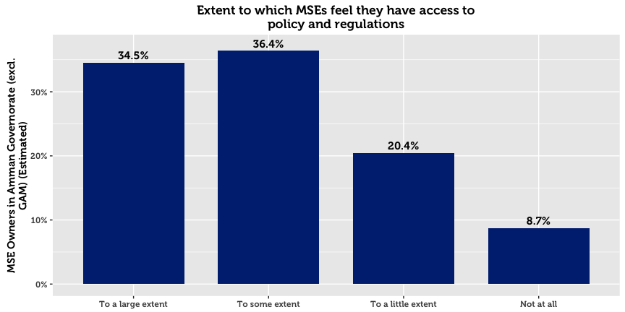

|  |  |  |  |  |  |
| --- | --- | --- | --- | --- | --- |
| **Policy Sources (Amman)** |  | **All** |  | **By Sex** | |
|  |  | *N* = 33,455 |  | Men | Women |
| Local Municipality |  | 27.6% |  | 28.1% | 22.7% |
| Family and friends |  | 24.4% |  | 25.1% | 17.1% |
| No use for this information |  | 11.6% |  | 10.9% | 19.3% |
| Lawyer |  | 11.1% |  | 11.8% | 3.4% |
| Government Website |  | 10.1% |  | 9.9% | 11.4% |
| Do not know |  | 4.9% |  | 4.2% | 11.7% |
| Local businesses and enterprises |  | 3.7% |  | 4.1% | 0.1% |
| Business support center |  | 0.7% |  | 0.6% | 1.0% |
| Refused to Answer |  | 0.4% |  | 0.5% | 0.0% |
| Other |  | 5.5% |  | 4.7% | 13.4% |

1. In this paper, micro- and small-enterprises are categorized in accordance with USAID LENS’ definition. A business (formal or otherwise) having fewer than 10 full-time employees (excluding the owner) is classified as a microenterprise, whereas businesses with 10 to 49 full-time employees, are categorized as small.
2. Throughout this paper, the area of “Amman” refers to the geographic area of Amman governorate, excluding the Greater Amman Municipality (“GAM”) which was excluded from the study. The area of “Aqaba” refers to the Aqaba Governorate, excluding the Aqaba Special Economic Zone (“ASEZA”).
3. Although results are representative of MSEs within each geographic area, results cannot be disaggregated on a more granular geographic level without compromising on acceptable sampling error rates. This is due to the clustering design in the first phase.
4. This total represents an estimate for the total number of MSE-owners, without accounting for multiple ownership. The survey reveals that 8.2% of business owners in Amman have a second business. The total number of MSEs is therefore higher than the total number of MSE owners. Throughout this report, we relax this strict distinction and commonly use language such as “X% of MSEs…” when referring to data about MSE owners.
5. In this report, “Population Estimate” means the absolute number of MSE owners in Amman, estimated using inclusion probabilities from the random sample. This statistical definition of “population” is not the same as the general understanding of the word in everyday language, which refers to the total number of people living within the boundaries of a nation state. Although many statistical publications use or when referring to these estimates, in this report we use the more intuitive notation *N* to denote population estimates, and *n* to denote unweighted sample counts.
6. Four sectors are examined throughout this report: Tourism, ICT, Transport, and Food Processing. These groupings are created on the basis ISIC-4 classifications collected in the survey, and are the primary data to reflect the four target sectors used for interventions in the LENS project.
7. In this report, a home-based business is any enterprise or income-generating project that operates from the owner’s home. As a result, this definition does not include MSEs operating in the homes of clients (maids, personal care, etc.).
8. 4,183 out of 33,455 businesses in Amman Governorate lost employees in the last 12 months.
9. Due to an error in the tablet software used for interviews, questions concerning technical assistance were only posed to MSE owners with employees.
10. Understood as financial or resource contributions from an international or local agency.
11. 8,698 businesses are in at least one business association